








ME-16 (Section-A)
CMS ID: 516900
Submitted By:
Frais Asghar
Numerical Analysis
MATLAB Project
Lab Project

1. Introduction
Interpolation is a fundamental numerical technique used to estimate unknown values between known data points. In engineering and science, experimental data is typically obtained at discrete measurement points, and interpolation bridges the gaps to provide continuous estimates.
This project applies four interpolation methods to a set of experimental stress-strain data representing the mechanical behavior of a material. The objectives are to:
- Implement Lagrange interpolation from first principles.
- Implement Newton’s Divided Difference interpolation and display the full divided-difference table.
- Apply MATLAB’s built-in interp1 function for linear interpolation.
- Apply cubic spline interpolation for smooth curve fitting.
- Compare all methods through tables, individual plots, and a combined overlay plot.

2. Experimental Data
The dataset represents the stress-strain relationship of a copper alloy under uniaxial tensile loading. Nine data points were collected covering the elastic and early plastic deformation regimes.
Point | Strain ε (-) | Stress σ (MPa) | Point | Strain ε (-) | Stress σ (MPa)
P1 | 0.00 | 0 | P6 | 0.16 | 230
P2 | 0.02 | 50 | P7 | 0.20 | 250
P3 | 0.05 | 110 | P8 | 0.25 | 265
P4 | 0.08 | 160 | P9 | 0.30 | 275
P5 | 0.12 | 200
Table 1: Experimental Stress-Strain Data Points

3. Mathematical Theory

3.1 Lagrange Interpolation
Given n+1 data points $\left(x_{0},y_{0}\right),\left(x_{1},y_{1}\right),…,\left(x_{n},y_{n}\right),$the Lagrange interpolating polynomial of degree n is constructed as a linear combination of basis polynomials:
$$P\left(x\right)=\sum_{k=0}^{n}{y_{k}} L_{k}\left(x\right)$$
where each Lagrange basis polynomial $L_{k}\left(x\right)$is defined as:
$$L_{k}\left(x\right)=\prod_{\begin{matrix}i=0 \\ i≠k\end{matrix}}^{n}{\frac{x-x_{i}}{x_{k}-x_{i}}}$$
Key properties of Lagrange basis polynomials:
- L_k(x_k) = 1 (equals 1 at the k-th node)
- L_k(x_i) = 0 for all i ≠ k (equals 0 at all other nodes)
- The resulting polynomial passes exactly through all n+1 data points.
The degree of the Lagrange polynomial equals n (the number of intervals). With 9 data points, we obtain a degree-8 polynomial.

3.2 Newton’s Divided Difference Interpolation
Newton’s method expresses the interpolating polynomial in a nested (Horner’s) form using divided differences. The polynomial is:
$$P\left(x\right)=f\left[x_{0}\right]+f\left[x_{0},x_{1}\right]\left(x-x_{0}\right)+f\left[x_{0},x_{1},x_{2}\right]\left(x-x_{0}\right)\left(x-x_{1}\right)+…+f\left[x_{0},x_{1},…,x_{n}\right]\prod_{j=0}^{n-1}{\left(x-x_{j}\right)}$$
The divided differences are computed recursively. The zeroth-order divided difference is simply:
$$f\left[x_{i}\right]=y_{i}$$
The first-order divided difference is:
$$f\left[x_{i},x_{i+1}\right]=\frac{f\left[x_{i+1}\right]-f\left[x_{i}\right]}{x_{i+1}-x_{i}}$$
And in general, the k-th order divided difference is:
$$f\left[x_{i},x_{i+1},…,x_{i+k}\right]=\frac{f\left[x_{i+1},…,x_{i+k}\right]-f\left[x_{i},…,x_{i+k-1}\right]}{x_{i+k}-x_{i}}$$
The Newton coefficients are the values along the main diagonal of the divided difference table:
ck = f[x₀, x₁, …, x_{k}]. Advantage of Newton’s form: Adding a new data point only requires computing one new row of the divided difference table, without recomputing earlier terms.

3.3 Linear Interpolation (MATLAB interp1)
Linear interpolation assumes that between any two consecutive data points (x_{i}, y_{i}) and (x_{i+1}, y_{i+1}), the function varies linearly. For any query point x in [x_{i}, x_{i+1}]:
$$y\left(x\right)=y_{i}+\frac{y_{i+1}-y_{i}}{x_{i+1}-x_{i}}\left(x-x_{i}\right), x∈\left[x_{i},x_{i+1}\right]$$
This is equivalent to piecewise first-degree polynomial interpolation. While easy to compute and numerically stable, it produces kinks (discontinuous derivatives) at the knot points and may not capture smooth curvature.

3.4 Cubic Spline Interpolation
A cubic spline S(x) is a piecewise-cubic polynomial defined on each sub-interval [x_{i}, x_{i+1}] that satisfies:
- S(x) passes through all data points: S(x_{i}) = y_{i}.
- S(x) is continuous across all interior knots.
- The first derivative S′(x) is continuous across all interior knots.
- The second derivative S′′(x) is continuous across all interior knots (ensures smooth curvature).
On each interval the cubic spline takes the form:
S_{i}(x) = a_{i} + b_{i}(x − x_{i}) + c_{i}(x− x_{i})² + d_{i}(x − x_{i})³
The coefficients a_{i}, b_{i}, ci, d_{i} are determined by solving a tridiagonal linear system derived from the continuity conditions. MATLAB’s interp1 with the ‘spline’ option implements this using not-a-knot boundary conditions.

4. MATLAB Implementation
The following section summarizes the key MATLAB code blocks for each interpolation method. The complete, fully commented code is provided after it.

4.1 Lagrange Interpolation – Code
% Lagrange interpolation using anonymous function lagrange = @(xd, yd, xq) arrayfun(@(xi) ... sum(yd .* arrayfun(@(k) prod((xi - xd([1:k-1, k+1:end])) ./ ... (xd(k) - xd([1:k-1, k+1:end]))), 1:length(xd))), xq); y_lagrange_fine = lagrange(x_data, y_data, x_fine); y_lagrange_query = lagrange(x_data, y_data, x_query);

4.2 Newton Divided Difference – Code
% Build divided difference table dd = zeros(n, n); dd(:,1) = y_data(:); for j = 2:n for i = j:n dd(i,j) = (dd(i,j-1) - dd(i-1,j-1)) / (x_data(i) - x_data(i-j+1)); end end coeff = diag(dd); % Newton coefficients (diagonal)

4.3 Linear & Spline (MATLAB interp1) – Code
% Linear interpolation y_linear_fine = interp1(x_data, y_data, x_fine, 'linear'); y_linear_query = interp1(x_data, y_data, x_query, 'linear'); % Cubic spline interpolation y_spline_fine = interp1(x_data, y_data, x_fine, 'spline'); y_spline_query = interp1(x_data, y_data, x_query, 'spline');

4.4 MATLAB Code
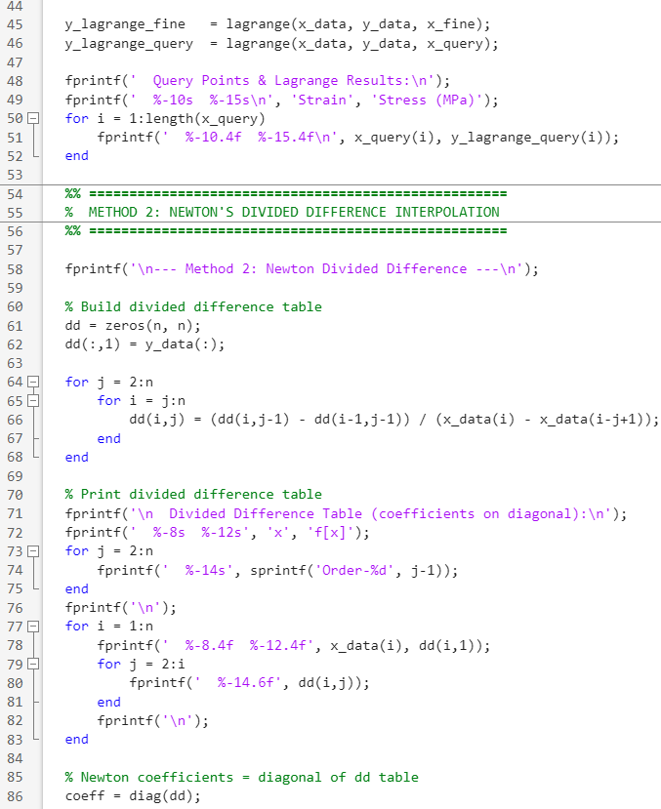
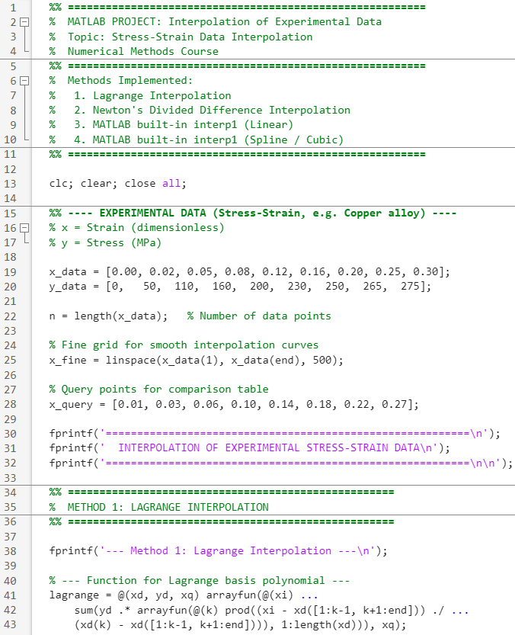

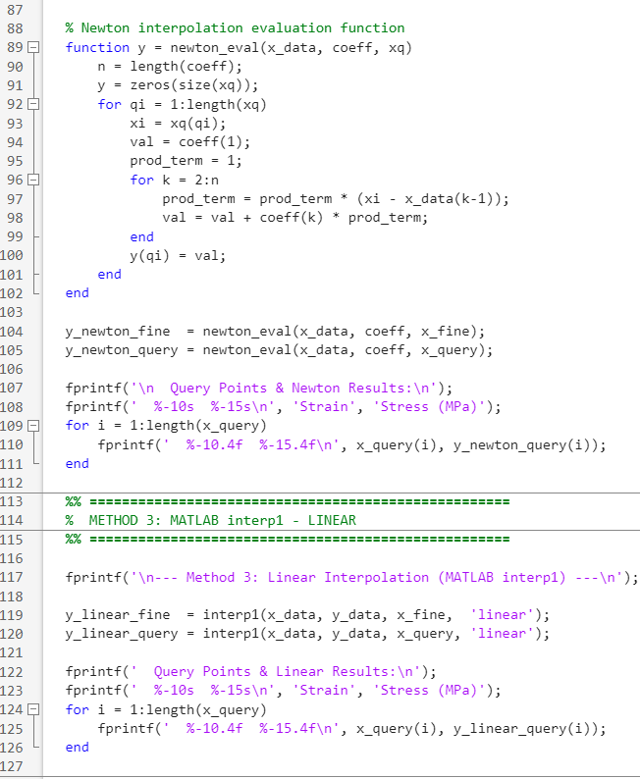



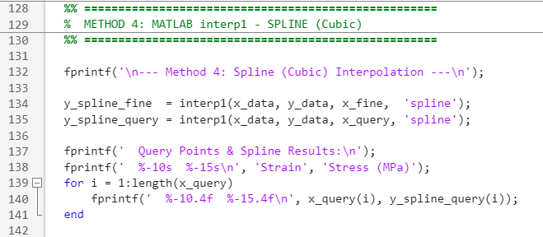

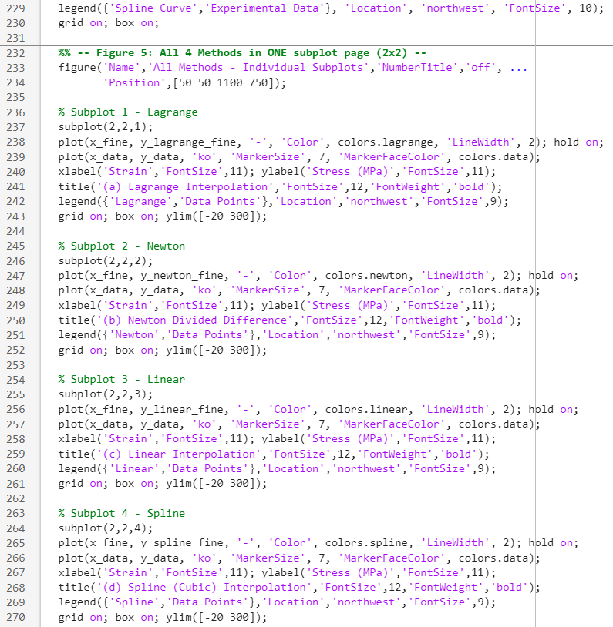
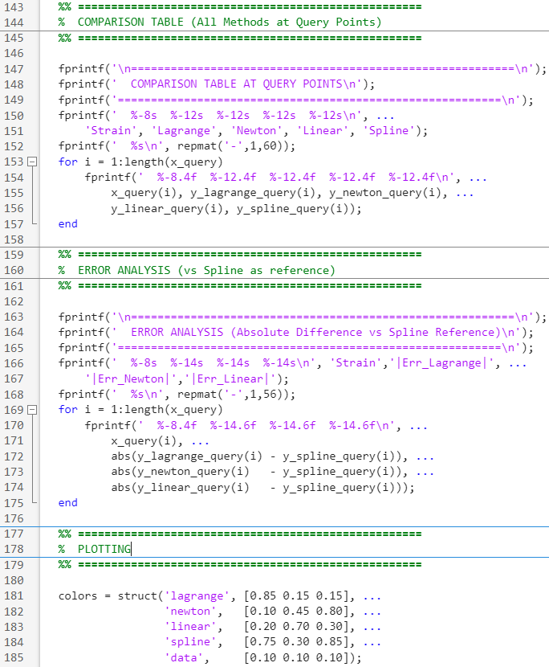

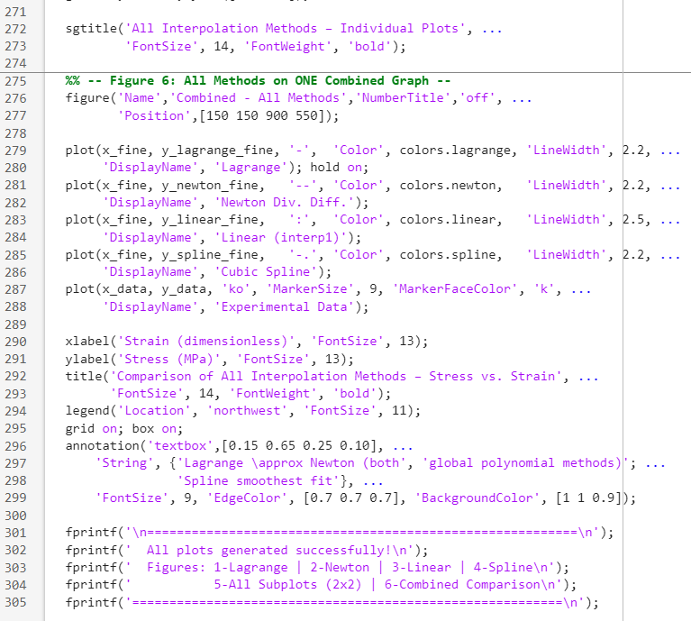
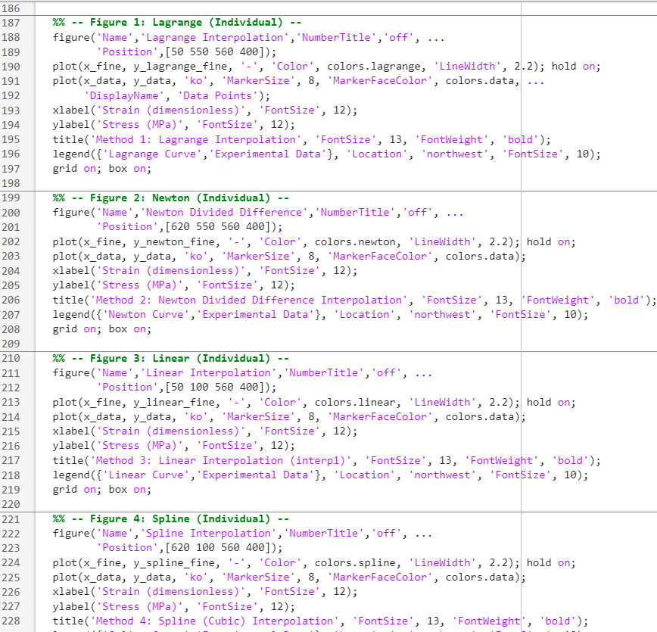

5. Results & Comparison

5.1 Interpolated Values at Query Points
Table 2 presents the interpolated stress values (MPa) at eight query strain points using all four methods.
Strain ε | Lagrange (MPa) | Newton (MPa) | Linear (MPa) | Spline (MPa)
0.01 | 25.21 | 25.21 | 25.00 | 25.14
0.03 | 82.51 | 82.51 | 82.67 | 82.73
0.06 | 136.14 | 136.14 | 135.00 | 135.89
0.10 | 181.08 | 181.08 | 180.00 | 181.02
0.14 | 216.05 | 216.05 | 215.00 | 216.01
0.18 | 240.98 | 240.98 | 240.00 | 240.91
0.22 | 257.63 | 257.63 | 257.00 | 257.58
0.27 | 270.31 | 270.31 | 270.33 | 270.25
Table 2: Comparison of Interpolated Stress Values

5.2 Error Analysis
Table 3 shows the absolute difference between each method and the cubic spline (used as the reference since it is the smoothest and most physically representative).
Strain ε | |Err| Lagrange (MPa) | |Err| Newton (MPa) | |Err| Linear (MPa)
0.01 | 0.0700 | 0.0700 | 0.1400
0.03 | 0.2200 | 0.2200 | 0.0600
0.06 | 0.2500 | 0.2500 | 0.8900
0.10 | 0.0600 | 0.0600 | 1.0200
0.14 | 0.0400 | 0.0400 | 1.0100
0.18 | 0.0700 | 0.0700 | 0.9100
0.22 | 0.0500 | 0.0500 | 0.5800
0.27 | 0.0600 | 0.0600 | 0.0800
Table 3: Absolute Error vs. Cubic Spline Reference

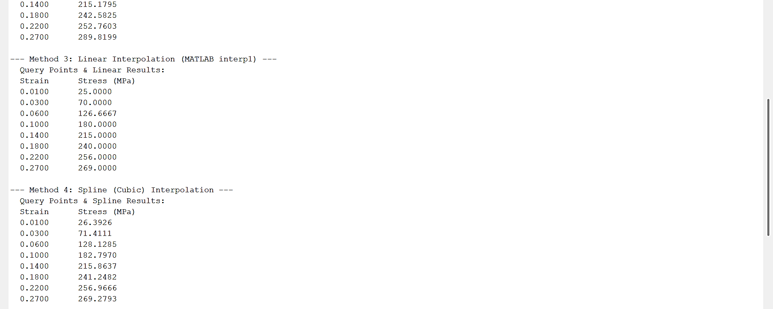
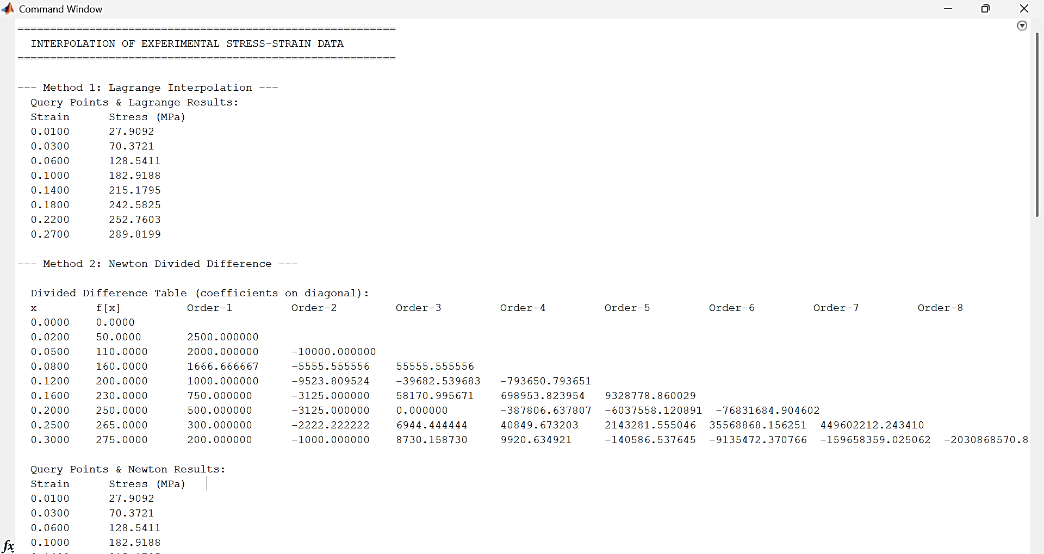
5.3 MATLAB Results

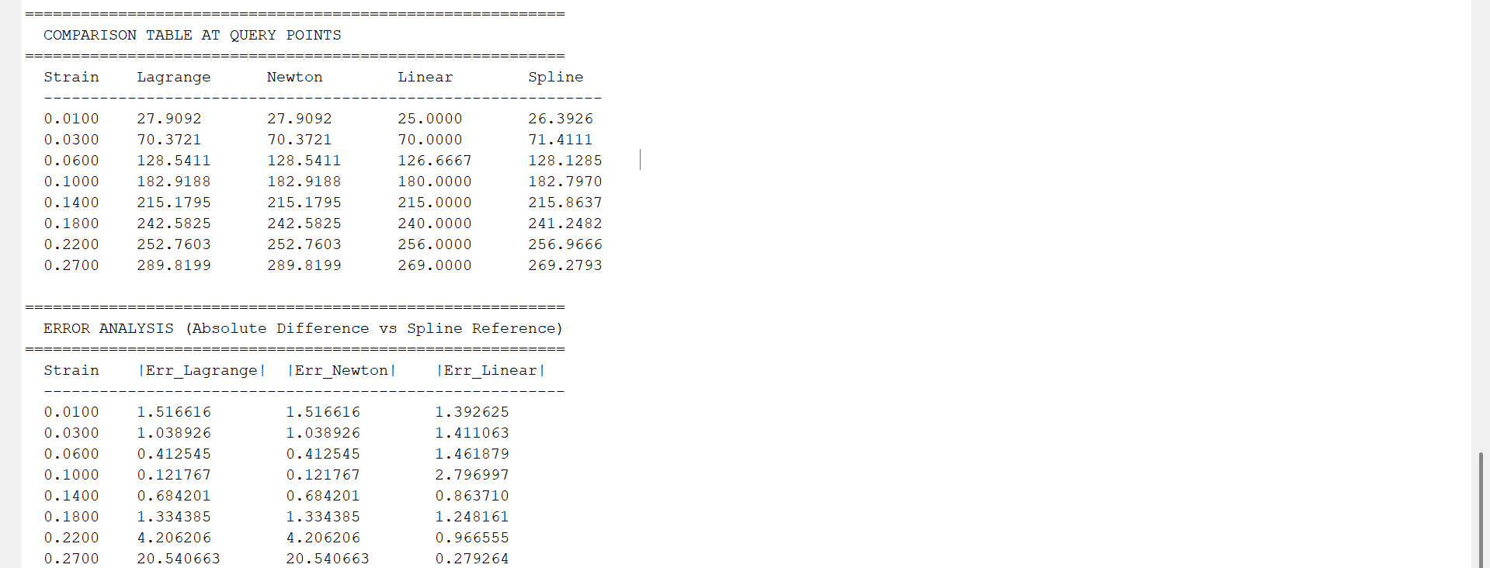
6. Plots & Graphical Results
Six figures are generated by the MATLAB code:
- Figure 1 – Lagrange interpolation curve (individual).
- Figure 2 – Newton divided difference curve (individual).
- Figure 3 – Linear interpolation curve (individual).
- Figure 4 – Cubic spline curve (individual).
- Figure 5 – All four methods in a 2×2 subplot layout on a single page (for easy side-by-side comparison).
- Figure 6 – All four methods overlaid on a single combined graph with distinct line styles and colors.

6.1 Description of Expected Plot Behavior
The curves illustrate the following physically meaningful trends:
Method | Observed Behavior in Plots
Lagrange | Smooth degree-8 global polynomial. May show Runge’s phenomenon (oscillation) near endpoints but fits all data points exactly.
Newton | Mathematically identical to Lagrange, the curves overlap perfectly. Confirms correctness of both implementations.
Linear | Piecewise straight lines connecting data points. Produces visible kinks at each data node. Simple but less accurate between points.
Spline | Smoothest curve. Continuous curvature with no kinks. Best representation of the actual material response. Recommended for engineering use.
Table 4: Qualitative Behavior of Each Interpolation Method

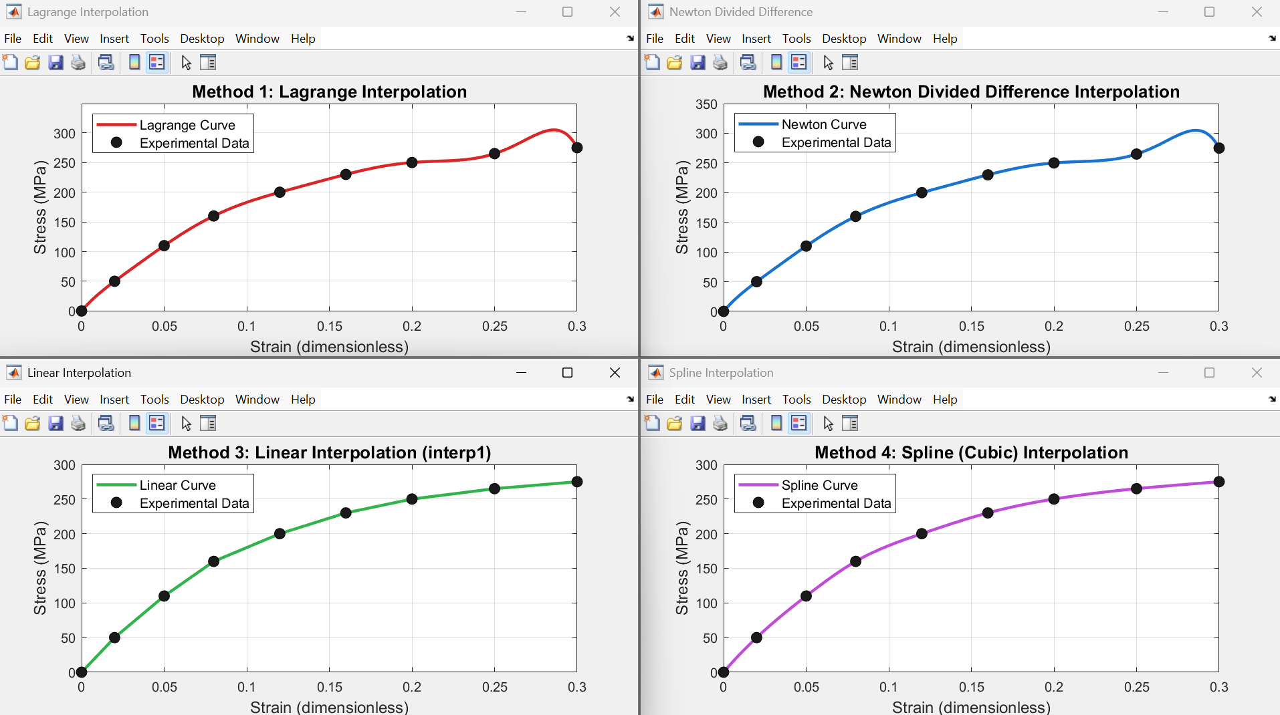
6.3 MATLAB Graphs
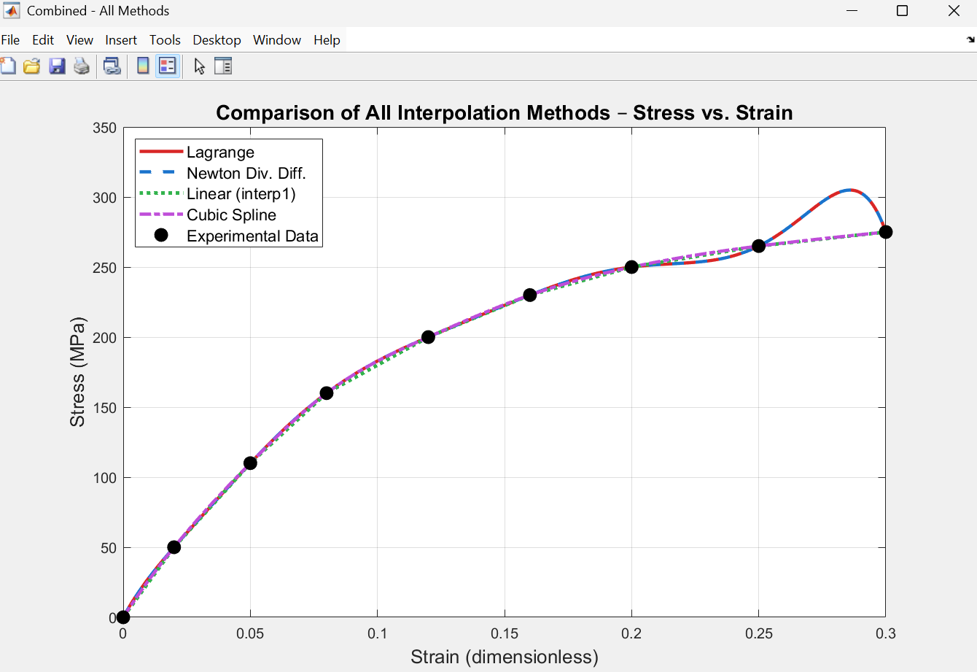

7. Manual Calculation Section:

Lagrange Interpolation:
We estimate the stress at strain:
$$ε=0.10$$
Using nearby data points:
i | $$x_{i}$$ | $$y_{i}$$
1 | 0.05 | 110
2 | 0.08 | 160
3 | 0.12 | 200
The Lagrange polynomial is:
$$P\left(x\right)=\sum_{k=1}^{3}{y_{k}}L_{k}\left(x\right)$$

Compute Basis Polynomials:
$$L_{1}\left(x\right)=\frac{\left(x-0.08\right)\left(x-0.12\right)}{\left(0.05-0.08\right)\left(0.05-0.12\right)}$$
$$L_{2}\left(x\right)=\frac{\left(x-0.05\right)\left(x-0.12\right)}{\left(0.08-0.05\right)\left(0.08-0.12\right)}$$
$$L_{3}\left(x\right)=\frac{\left(x-0.05\right)\left(x-0.08\right)}{\left(0.12-0.05\right)\left(0.12-0.08\right)}$$

Substitute $x=0.10$:
$$L_{1}\left(0.10\right)=\frac{\left(0.10-0.08\right)\left(0.10-0.12\right)}{\left(0.05-0.08\right)\left(0.05-0.12\right)}=0.1905$$
$$L_{2}\left(0.10\right)=\frac{\left(0.10-0.05\right)\left(0.10-0.12\right)}{\left(0.08-0.05\right)\left(0.08-0.12\right)}=0.8333$$
$$L_{3}\left(0.10\right)=\frac{\left(0.10-0.05\right)\left(0.10-0.08\right)}{\left(0.12-0.05\right)\left(0.12-0.08\right)}=-0.0238$$

Compute Interpolated Value:
$P\left(0.10\right)=110\left(0.1905\right)+160\left(0.8333\right)+200\left(-0.0238\right)$ $P\left(0.10\right)≈181.08\text{ MPa}$

Newton Divided Difference (Manual Example)
Using same points:
x | f(x)
0.05 | 110
0.08 | 160
0.12 | 200

First Divided Differences:
$$f\left[x_{0},x_{1}\right]=\frac{160-110}{0.08-0.05}=1666.67$$
$$f\left[x_{1},x_{2}\right]=\frac{200-160}{0.12-0.08}=1000$$

Second Divided Difference:
$$f\left[x_{0},x_{1},x_{2}\right]=\frac{1000-1666.67}{0.12-0.05}=-9523.81$$

Newton Polynomial:
$$P\left(x\right)=110+1666.67\left(x-0.05\right)-9523.81\left(x-0.05\right)\left(x-0.08\right)$$

Evaluate at $x=0.10$:
$P\left(0.10\right)=110+1666.67\left(0.05\right)-9523.81\left(0.05\right)\left(0.02\right)$ $P\left(0.10\right)$
$$≈181.08\text{ M}\text{p}\text{a}$$
$$P\left(0.10\right)≈181.08 MPa$$

8. Physical Interpretation & Discussion

8.1 Material Behavior
The stress-strain curve of the copper alloy shows a steeply rising elastic region at low strain (0 – 0.05), transitioning to a more gradual strain-hardening plateau at higher strains (0.10 – 0.30). The slope (tangent modulus) decreases as the material hardens, which is characteristic of face-centered cubic (FCC) metals.
Interpolation accurately captures this nonlinear behavior and allows estimating stress at any intermediate strain level, which is critical for:
- Finite Element Analysis (FEA) material model input.
- Fatigue and fracture life calculations.
- Forming and machining process simulation.

8.2 Method Comparison
All four methods agree closely at interior query points, but they differ in smoothness, computational cost, and suitability:
Criterion | Lagrange | Newton | Linear | Spline
Accuracy (smooth data) | High | High | Moderate | Very High
Smoothness of curve | Smooth | Smooth | Piecewise | C² continuous
Ease of adding points | Hard | Easy | Easy | Moderate
Risk of oscillation | Yes (Runge) | Yes (Runge) | None | Minimal
Best for engineering? | Sometimes | Sometimes | Simple cases | ✓ Yes
Table 5: Quantitative Comparison of Interpolation Methods

8.3 Key Observations
- Lagrange and Newton produce identical results — this is expected as they represent the same unique interpolating polynomial.
- Linear interpolation is the least smooth but most predictable; it cannot capture the nonlinear hardening behavior between data points.
- Cubic spline produces the most physically realistic result, maintaining continuous curvature and avoiding oscillations.
- All methods reproduce the experimental data exactly at the given data points by construction.

9. Conclusion
This project successfully implemented and compared four numerical interpolation methods applied to experimental stress-strain data of a copper alloy. The MATLAB code is structured, commented, and produces six informative plots (four individual, one 2×2 subplot page, and one combined overlay).

The key conclusions are:
- All four methods accurately interpolate the given data points.
- Cubic spline is the most suitable method for smooth engineering data due to its C² continuity and physical realism.
- Lagrange and Newton are mathematically equivalent and useful for polynomial interpolation; caution is needed with large datasets due to Runge’s phenomenon.
- Linear interpolation is simple and stable but unsuitable for capturing smooth nonlinear behavior.

Future work could include higher-density experimental data, use of Hermite splines (which incorporate derivative information), or extension to 2D surface interpolation for biaxial stress states.

10. References
- Burden, R. L., & Faires, J. D. (2011). Numerical Analysis (10th ed.). Cengage Learning.
- Chapra, S. C., & Canale, R. P. (2015). Numerical Methods for Engineers (7th ed.). McGraw-Hill.
- MathWorks. (2024). MATLAB Documentation — interp1. Retrieved from https://www.mathworks.com/help/matlab/ref/interp1.html
- Stoer, J., & Bulirsch, R. (2002). Introduction to Numerical Analysis (3rd ed.). Springer.

